

LA MENNAIS SCHOOLS ACADEMIC COMMITTEE

MID TERM II EXAMINATIONS

**ENGLISH P.1 2022**

Name:__________________________________________________________

School: _________________________________Stream__________________

**SECTION A**

**Name the pictures**

|  |  |  |  |
| --- | --- | --- | --- |
| 1. | 2. | 3. | 4. |
|  |  |  |  |

**Fill in the missing letters**

5. h___e 6. ___x___ 7. f___re 8. sn___ke

**Write in small letters**

9. WET = _______________ 10. SWEATER= __________________

11. SHIRT= ________________

**Write the words correctly.**

12. ssdre= ___________________ 13. coatrain= _________________

14. eoh= ____________________ 15. sketba= ___________________

16. ngapa= __________________

**Read and draw**

|  |  |  |  |
| --- | --- | --- | --- |
| 17. jacket | 18. insects | 19. shoes | 20. shirt |
|  |  |  |  |

**Give the plural of these words.**

table- tables 21. coat- ____________________

22. plant- ___________________ 23. weed- ___________________

24. helmet- __________________ 25. glove- __________________

**Add** “ing” **to the verb**

cut- cutting

26. plant- ____________________ 27. harvest- _________________

28. winnow- ___________________ 29. grow- ____________________

30. store- ____________________

**Use** “a” **or** “an”

31. This is ______umnrella.

32. Here is ______axe.

33. She has ______dress.

34. I have ______sweater

35. It is _______apple.

**Circle the rhyming word**

36. sun skin son can

37. light night kite right

38. duck pack dark dad

**Match these correctly**

sun head 39. _____________ ____________

clouds garden 40. _____________ ____________

farmer sky 41. ______________ ____________

helmet rain 42. ______________ ____________

**Write in ABC order**

43. pen axe book

____________________________________________________________

44. medicine, knife, cut

____________________________________________________________

45. insect, poison, burn, fire

____________________________________________________________

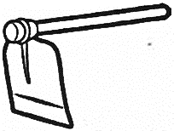 Use Yes, it is. / No, it is not.

46. Is this a panga?

_____________________________________________

47. Is it raining?

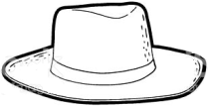 ______________________________________________

48 Is this a hut?

______________________________________________

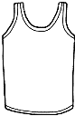**Write the number words**

49. Here is ___________vest.

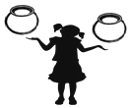

50. She has ___________pots

**SECTION B**

51. **Read and draw**

|  |  |  |
| --- | --- | --- |
| a) It is a knife | b) Here is an apple | These are rakes |
|  |  |  |
| A pair of trousers | | Father is digging |
|  | |  |

52. **What are these?** (clouds, boots, pangas, needle, axes)

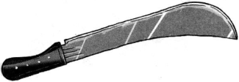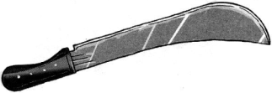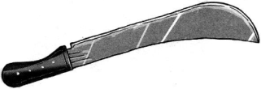 a) These are

_____________________

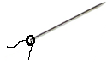

b)

______________________

 c) ­__________________________

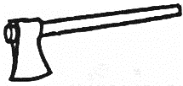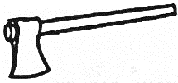

[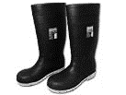](http://www.google.co.ug/imgres?imgurl=http://www.buyboots.com.au/webshots/oliver_10105_safety_gum_boots_with_steel_toes_-_waterpro_153_480.jpg&imgrefurl=http://www.buyboots.com.au/product_detail.asp?productnospaces=oliver_10105_safety_gum_boots_with_steel_toes_-_waterpro_153&usg=__fIuUqaDv_KPMLKcrin9Dlhg0wMQ=&h=480&w=640&sz=21&hl=en&start=3&zoom=1&tbnid=odsf3MhWLKxb_M:&tbnh=103&tbnw=137&ei=_Le2Te__IMnsOame5JIP&prev=/search?q=gumboots&hl=en&sa=N&gbv=2&tbm=isch&itbs=1) d) ______________________________________

e) ___________________________

53. **Write the sentences correctly.**

a) digging He is. ______________________________________

b) an orange is This. ______________________________________

c) this What is? ______________________________________

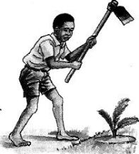 **What is he doing?** (reading, digging, jumping)

d)

__________________________________________

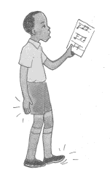

e) __________________________________________

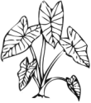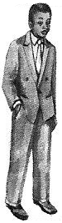54. **Fill in the correct word.** (hoe, farm, plants, rake father)

My ___________is a farmer. He has many ______

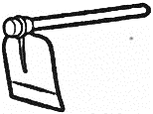

on his ____________. He has a __________ and a ______

55. **Make five sentences from the table.**

|  |  |  |
| --- | --- | --- |
| She  The pupils  It | are  is  has | wearing  listening to the teacher  weeding  raining  a rain coat |

a) _________________________________________________________

b) _________________________________________________________

c) _________________________________________________________

d) _________________________________________________________

e) _________________________________________________________

***\*\*\*\*\*\*\*\*\*\*\*GOD BLESS\*\*\*\*\*\*\*\*\*\****